2520090016
P.Rahul
OSSP

Task-2: Using Linux terminal commands (uname, lscpu, ps, top), investigate the relationship between hardware resources and operating system services. Prepare a report explaining how the OS abstracts CPU, memory, storage, and I/O devices.

Aim
To investigate the relationship between hardware resources and operating system services using Linux commands (uname, lscpu, ps, and top) and understand how the operating system abstracts CPU, memory, storage, and I/O devices.

Software Requirement
- Ubuntu Linux
- Terminal
Commands Used
1. ps
2. top

Screenshots
ps Command:
Purpose: Displays active processes with PID, TTY, TIME and CMD.
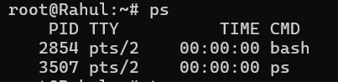

top Command:
Purpose: Displays real-time CPU, memory and process usage.

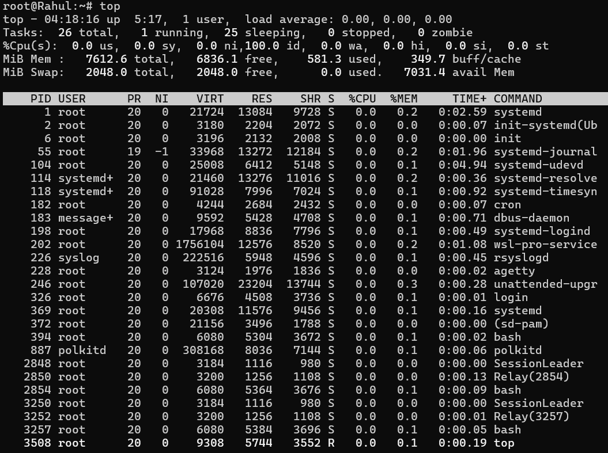

Hardware Resource Abstraction
CPU
The OS schedules processes and performs context switching.
Memory
The OS allocates RAM, provides virtual memory and protects processes.
Storage
The OS manages files using a file system and hides physical storage.
I/O Devices
The OS communicates with devices through device drivers.

Relationship Between Hardware Resources and OS Services
CPU → Process scheduling
Memory → Memory allocation and virtual memory
Storage → File system management
I/O Devices → Device drivers and interrupt handling
Result
The Linux commands were executed successfully. The experiment demonstrated how the operating system abstracts hardware resources and provides services for CPU, memory, storage and I/O devices.

